**Task Description** :

**Part 1:** Explore the methodologies and possibilities that can be implemented in load balancing and creating an application with high availability.

**Part 2:** Implement one of the explored methodologies in real time.

**Part 1:** Explore the methodologies and possibilities that can be implemented in load balancing and creating an application with high availability.

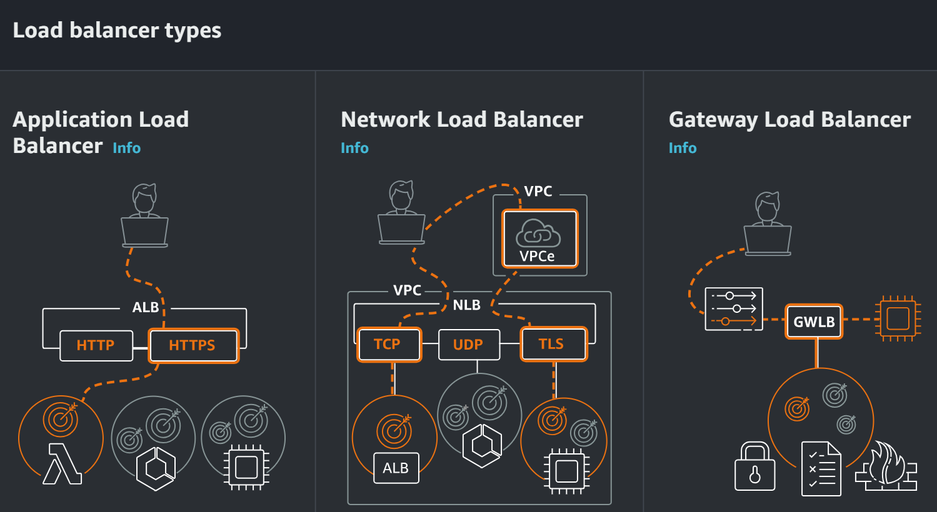

**Application Load Balancer :**

Choose an Application Load Balancer when you need a flexible feature set for your applications with HTTP and HTTPS traffic. Operating at the request level, Application Load Balancers provide advanced routing and visibility features targeted at application architectures, including microservices and containers.

**Network Load Balancer :**

Choose a Network Load Balancer when you need ultra-high performance, TLS offloading at scale, centralized certificate deployment, support for UDP, and static IP addresses for your applications. Operating at the connection level, Network Load Balancers are capable of handling millions of requests per second securely while maintaining ultra-low latencies.

**Gateway Load Balancer :**

Choose a Gateway Load Balancer when you need to deploy and manage a fleet of third-party virtual appliances that support GENEVE. These appliances enable you to improve security, compliance, and policy controls.

Step 1: Create 2 instances with the following “In Bound Rules”

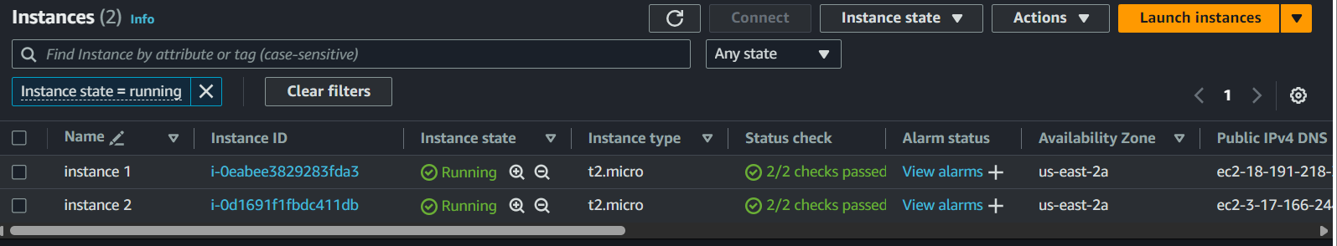

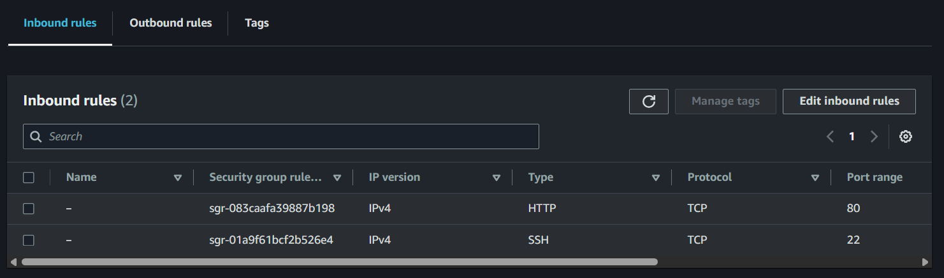

Step 2: Head to Load Balancers section to create Load Balancer. Here I’m selected Application Load Balancer

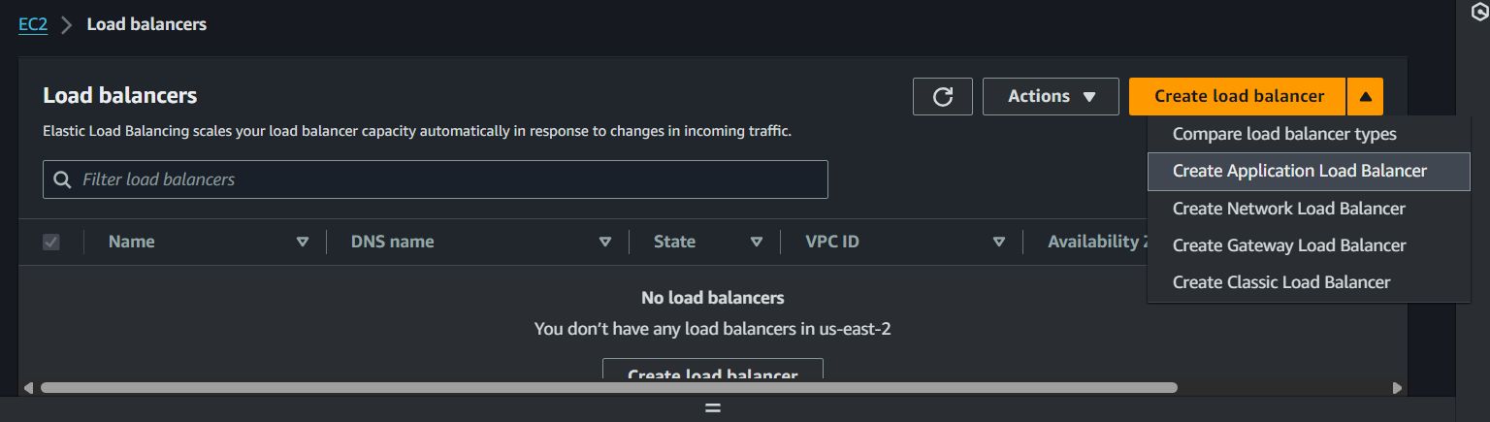

I provided the basic details and high availability

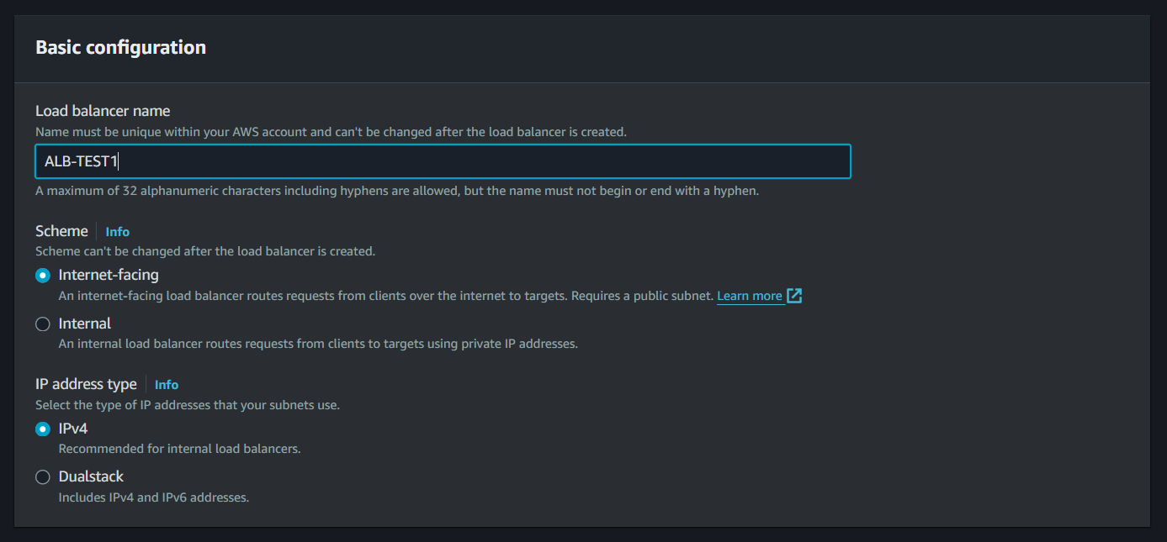

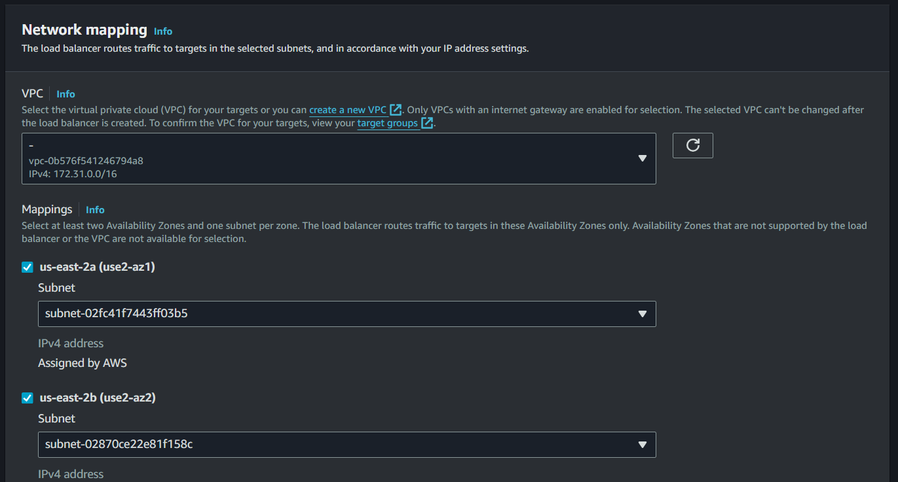

Here we have to add security groups, I’m creating a new security group

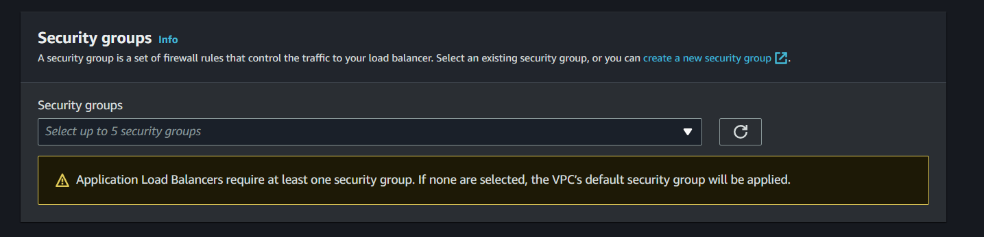

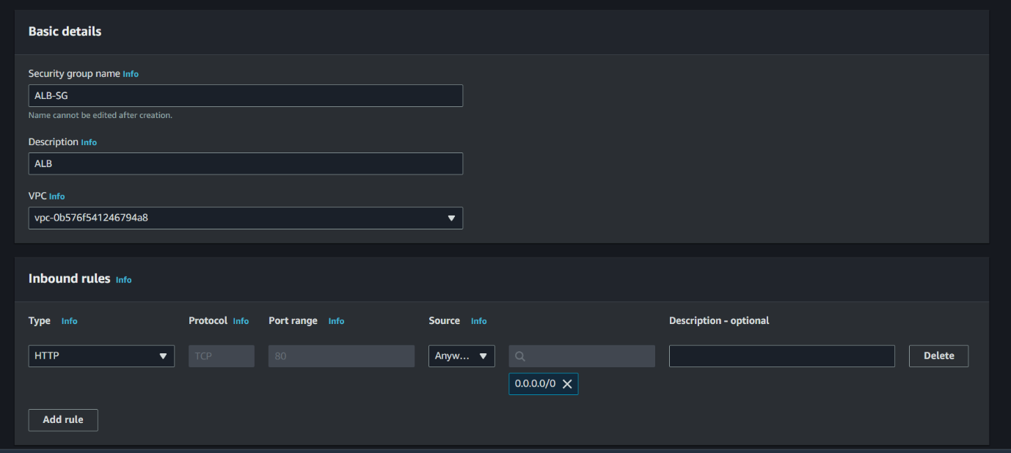

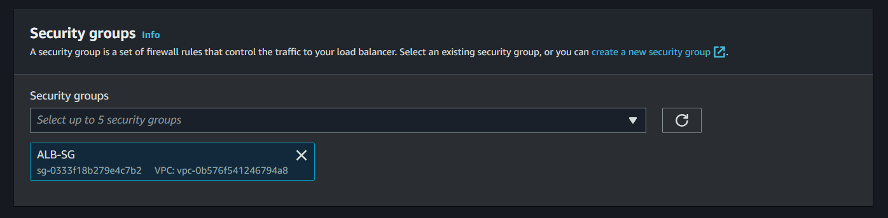

Step 3: add Target Group here, for that we have to create a Target group

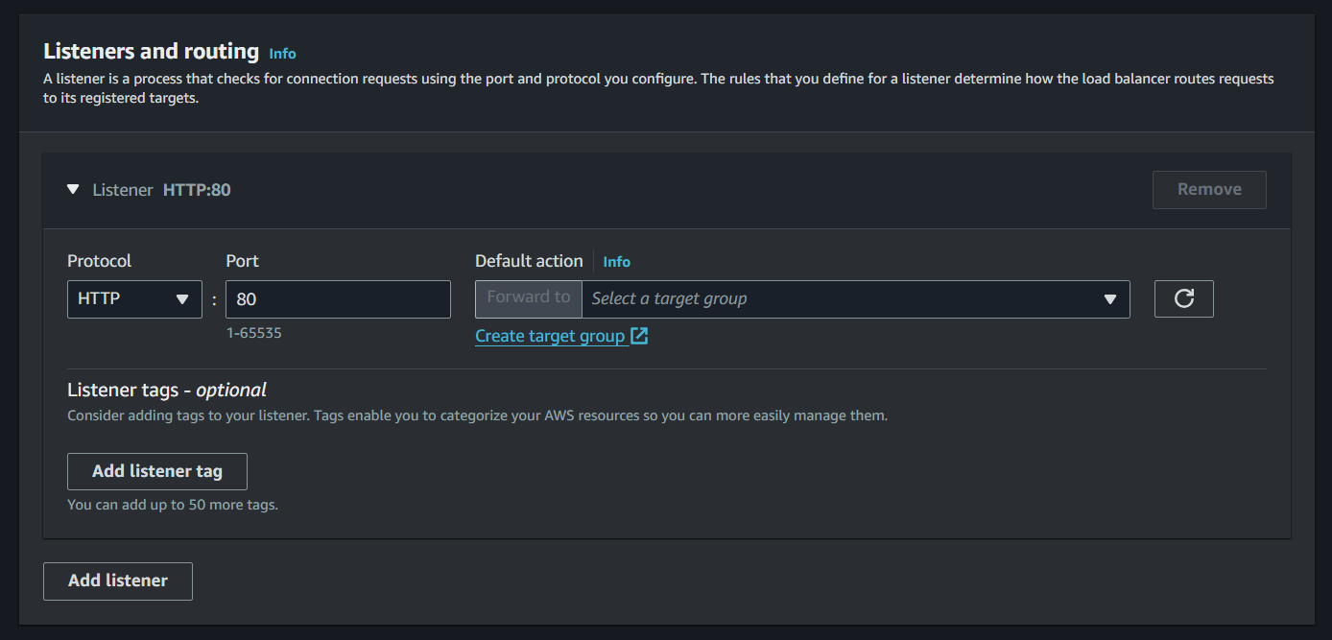

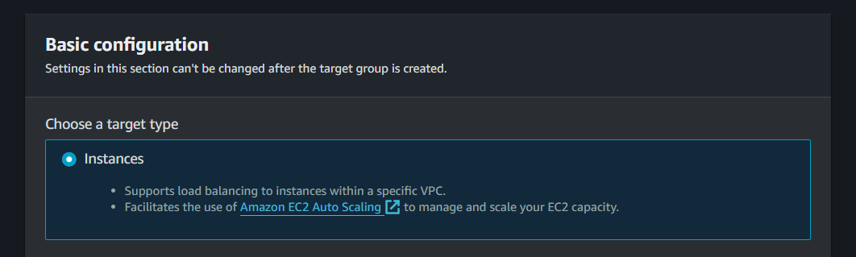

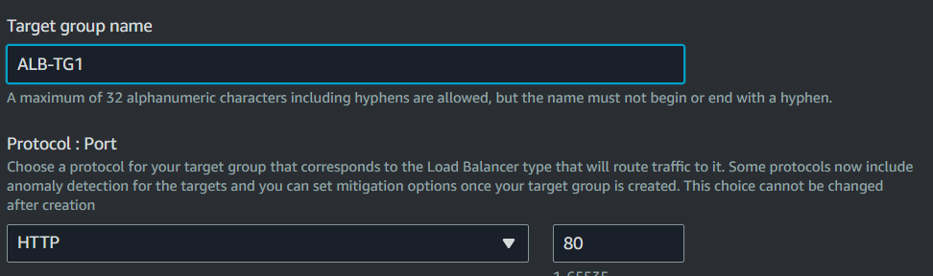

Step 4 : Add instances to Register targets

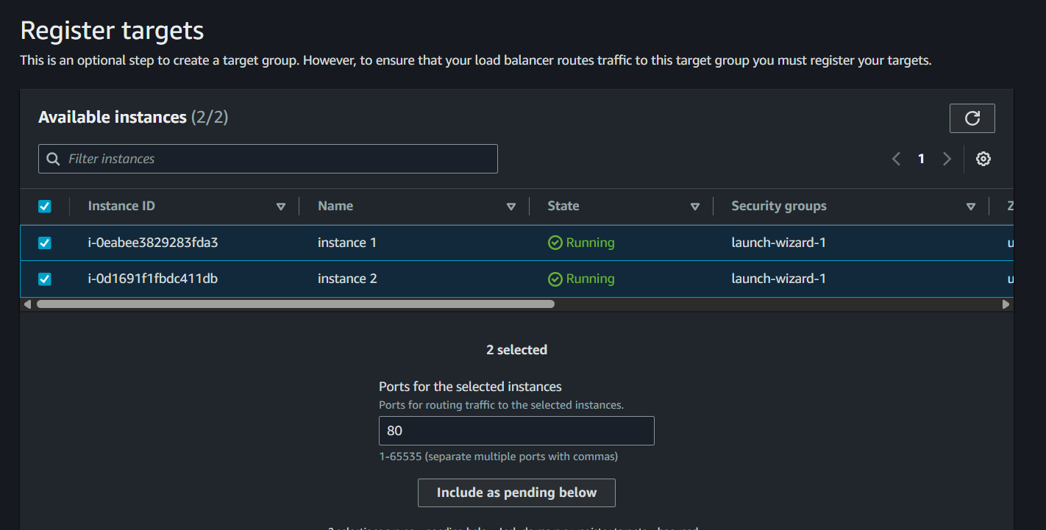

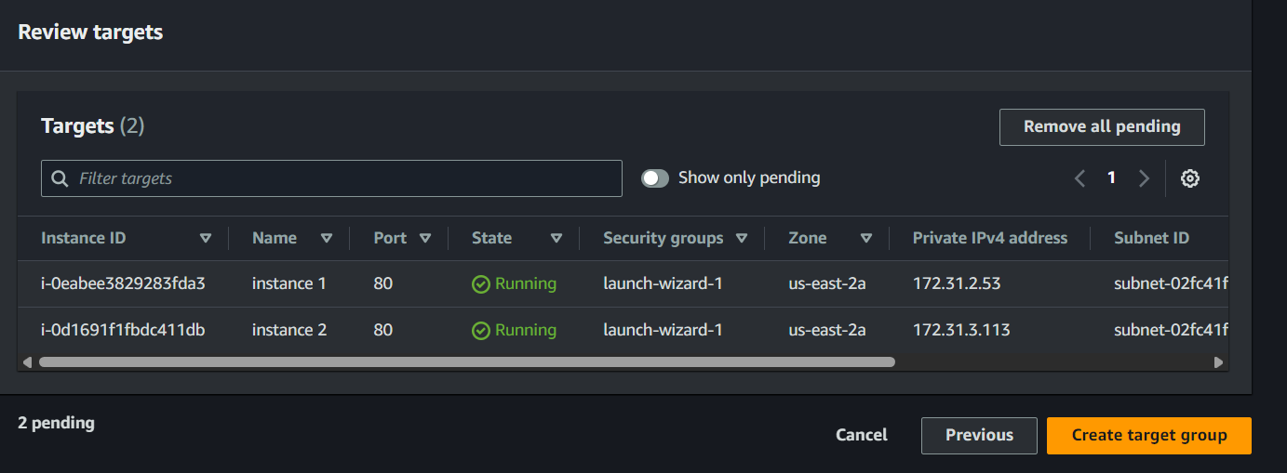

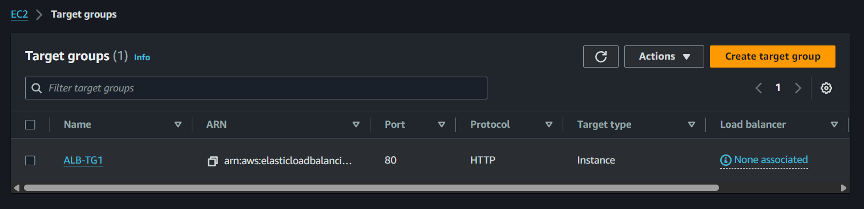

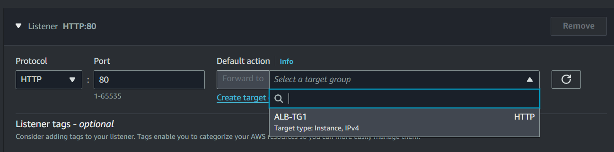

Now create the load balancer

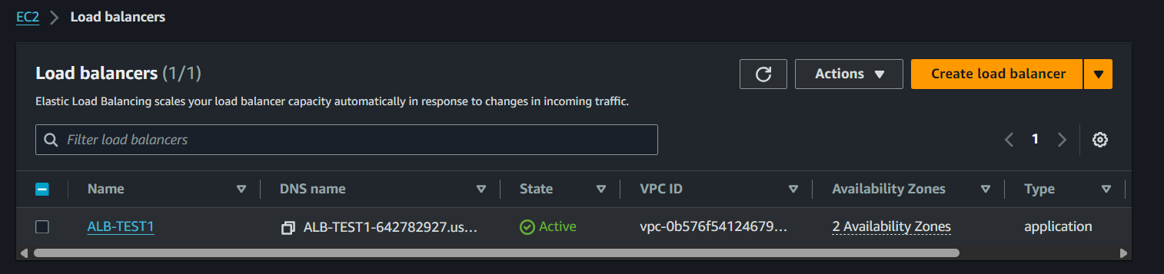

Now try task access your servers with public IP



Now copy the “DNS Name” of the Load Balancer and try to access from it



